W-12
YEAR 9 SCIENCE
EARTH AND SPACE SCIENCES
TEST

NAME: FORM: MARK: 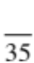

Achievement Standard: students explain global features and events in terms of geological
processes and timescales.

Part 1: Multiple Choice

Choose the correct answer for each question and write its letter in the appropriate box.

1. Which of the following statements is correct?
MULTIPLE CHOICE ANSWERS
1
2
3
4
5
6
7
8
9
10
11
12

(a) Tsunamis involve a lot of moving water, but not a lot of energy.
(b) Tsunamis are only dangerous when they reach a coastline.
(c) Tsunamis are caused by underwater volcanoes.
(d) Tsunamis are caused by tides.

2. Which of the following statements is correct?

(a) The boundaries of the Earth's crustal plates are regions of great
stability.
(b) Volcanoes can only erupt on the land, where they form large craters.
(c) Volcanoes are places on the Earth's crust where molten material from
inside the Earth comes to the surface.
(d) Earthquakes are caused by volcanoes erupting.

3. Earthquakes and volcanoes are often found together because:

(a) they are both produced by movement of crustal plates.
(b) earthquakes cause volcanoes.
(c) both are formed in the same way.
(d) volcanoes cause earthquakes.

4. What is meant by the term ‘magma’?

(a) Magma is a rock that has solidified from molten rock.
(b) Magma is molten rock that has flowed out onto the Earth’s surface.
(c) Magma is molten rock under the surface of the Earth.
(d) Magma is an igneous rock such as granite.

5. The inside of the Earth consists of four major layers. Which is the hottest layer?

(a) mantle
(b) outer core
(c) crust
(d) inner core

6. Which layer of the Earth causes the movement of the continents?

(a) mantle
(b) outer core
(c) crust
(d) inner core
7. Which of the following statements is correct?

(a) Volcanoes can only erupt on the land, where they form large craters.
(b) Volcanoes are places on the Earth's crust where molten material from inside the Earth comes to
the surface.
(c) Earthquakes are caused by volcanoes erupting.
(d) The boundaries of the Earth's crustal plates are regions of great stability.

8. Areas of the Earth where new crust is being formed are called:

(a) continental plates.
(b) subduction zones.
(c) ocean trenches.
(d) mid-ocean ridges.

9. What occurs at a subduction zone?

(a) An oceanic plate is rising to the surface and forming new land.
(b) An oceanic plate is submerging beneath a continental plate.
(c) A continental plate is submerging beneath an oceanic plate.
(d) The crustal plates are moving apart and forming new land.

10. The Earth's crust is broken into many plates that appear to float and move. Explain this movement.

(a) Over millions of years, ice ages have caused different temperatures that allow convection of
water currents.
(b) The oceans cause weathering and erosion, which makes plates move.
(c) The asthenosphere is molten and develops convection currents that move the plates.
(d) Magnetic fields cause the plates to be attracted towards the poles.

11. Alfred Wegener proposed a theory in which the continents split apart and moved. Name this original
supercontinent.

(a) Laurasia
(b) Pangaea
(c) Gondwana
(d) Wegenerville

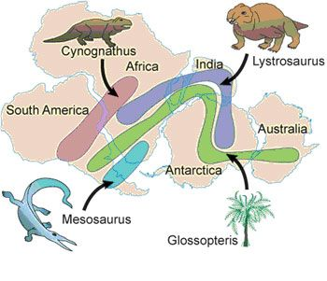
12. This diagram shows fossil evidence to support the idea that
the continents were once joined. Identify the organism not
found across South America.

(a) Mesosaurus
(b) Glossopteris
(c) Cynognathus
(d) Lystrosaurus

Part 2: Short Answer

1. Label the following diagram showing the layers of the Earth, giving the state (solid, liquid, etc) of the
material found in each.

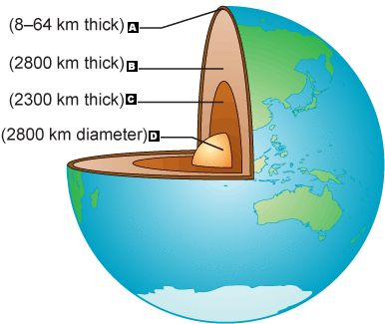

 | Name of layer | State (solid, liquid, etc)
A
B
C
D

(4 marks)

2. In the table below, choose the correct statement for each word given. Write the letter of the
correct statement next to the word.
(4 marks)
WORD | CORRECT  LETTER | STATEMENT
magma |  | A - how an organism looks due to its genes.
plate tectonics |  | B - one tectonic plate moves under another plate.
sea-floor spreading |  | C - formed by two plates sliding past each other.
convection current |  | D - theory that large plates of the Earth gradually  move.
transform boundary |  | E - theory that continents move through oceanic  crust.
subduction |  | F - hot liquid rock that comes up from the mantle.
converging boundary |  | G - theory that the middle of the ocean is spreading  apart.
continental drift |  | H - formed when two plates move towards each  other.

3. (a) Where on the surface of the Earth are most volcanoes found?

(1 mark)

(b) Explain why this is the case.

(1 mark)

4. Alfred Wegener pioneered the theory of continental drift. He assumed that all of the continents fitted
together in a "super continent" about 220 million years ago. They broke apart and started to drift
slowly apart.

(a) What name did he give to this "super continent"?

(1 mark)

(b) What evidence did Wegener use to support his theory? Give two points.

•

•

(2 marks)

(c) Explain what provides the force for the continental plates to move and drift.

(2 marks)

5. There are three possible plate combinations at converging boundaries. List the three combinations
and explain what landforms they form.

(i)

(ii)

(iii)

(6 marks)

6. In a spreading ridge the floor of the ocean moves out equally in opposite directions. Look at the following ‘side-on’ view of a spreading ridge. Which set of rocks would have the same age?

______________ _______________ _______________ __________________

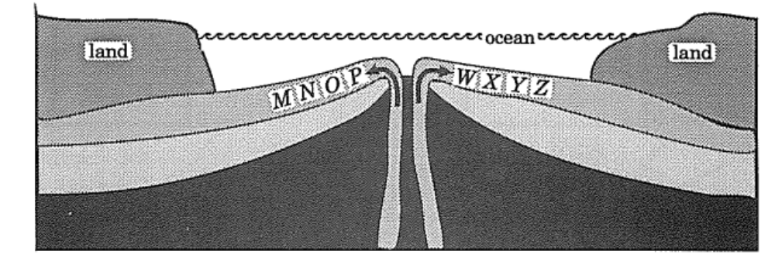

(2 marks)

AFTER YOU HAVE FINISHED THIS SECTION OF THE TEST MAKE SURE YOU CHECK YOUR ANSWERS CAREFULLY AGAIN AND THEN HAND IT INTO THE TEACHER. YOU WILL THEN BE GIVEN THE THIRD SECTION OF THE TEST TO COMPLETE.

Part C – Comprehension of a scientific piece of writing.

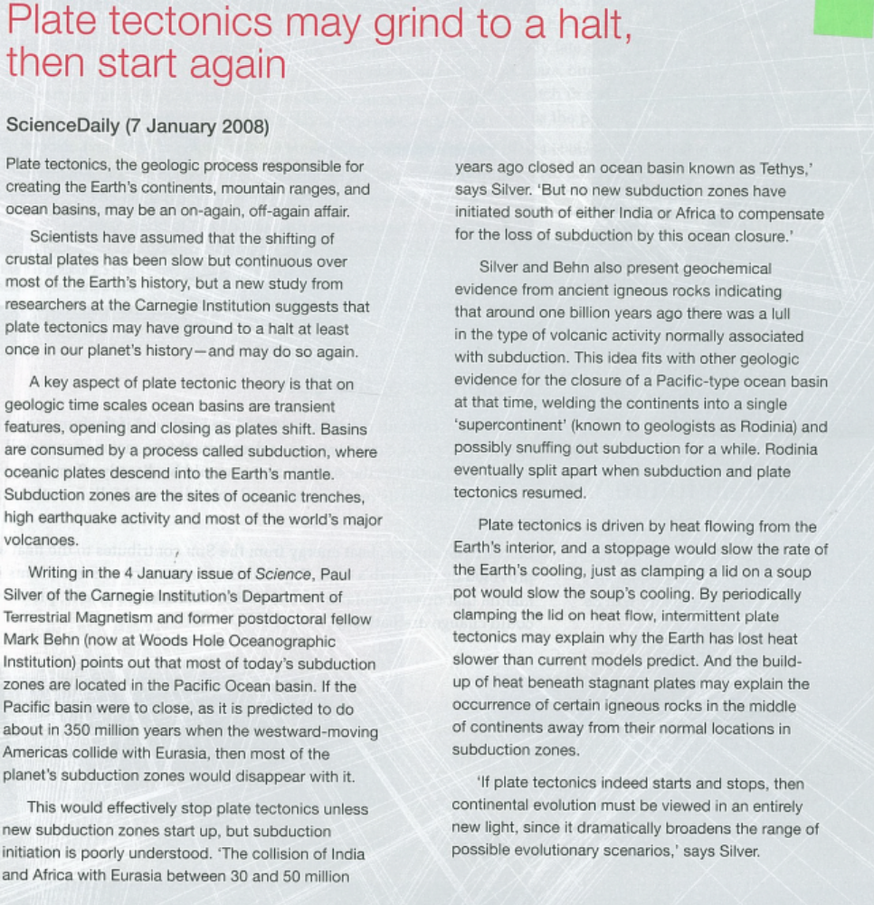

Answer the following questions in the Blog set up for your class on the Science Year 9 Moodle page.

1. What assumption have scientists made about plate tectonics that may not be true?
2. What geological process consumes ocean basins?
3. What are the common features of subduction zones?
4. Where are most of the world’s subduction zones?
5. Does the loss of the Earth’s heat provide evidence for continual motion of the plates or
stop-start motion?
6. Find out about the supercontinent Rodinia – did it come before or after Pangaea?

